## CASE STUDY

# Customer Service Requests Analysis

Thank you so much to our mentor

***AKSHATHA SHETTY***

for keeping us engaged, learning

ALSO

Thanks to SIMLILEARN TEAM

**Background of Problem Statement**

NYC 311's mission is to provide the public with quick and easy access to all New York City government services and information while offering the best customer service. Each day, NYC311 receives thousands of requests related to several hundred types of non-emergency services, including noise complaints, plumbing issues, and illegally parked cars. These requests are received by NYC311 and forwarded to the relevant agencies such as the police, buildings, or transportation. The agency responds to the request, addresses it, and then closes it.

**Problem Objective**

Perform a service request data analysis of New York City 311 calls. You will focus on the data wrangling techniques to understand the pattern in the data and also visualize the major complaint types.

# Process Adopted to Get Goel:

# Few python library used are

# Numpy

# Pandas

# Scipy

# Matplotlib

# Data wrangling done after reading data file.

# Process involve

# Checking columns for NULL values

# Creating few column like Request_Closing_Time(difference of close date and created date)

# Request_Closing_Time_inhr for rule out problem

# Replace Null values

# Visualization of few patterns like status

# The status of tickets plot (1)

# Majority of complaint types plot(2)

# Last 10 least of complaint types plot(3)

# Complaints Type by Location Type plot(4)

# The status of tickets

# 

# 2. Majority of complaint types

**3**. Last 10 least of complaint types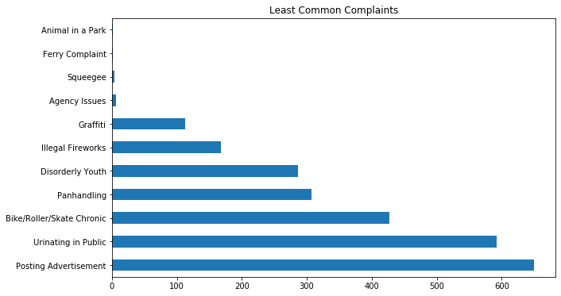

4.Complaints Type by Location Type

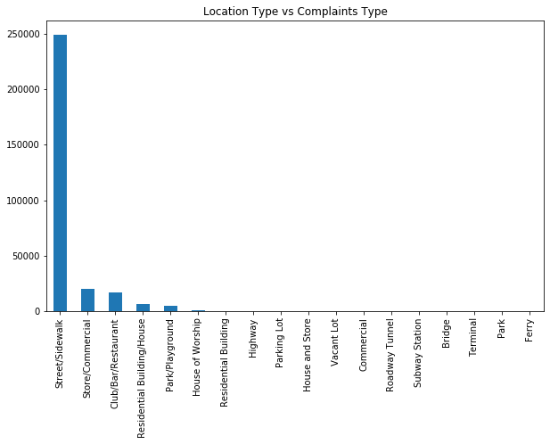

**To state the Null and Alternate and then provide a statistical test to accept or reject the Null Hypothesis along with the corresponding ‘p-value’.**

For prove above we have done a ANOVA test

For that we create new field name **Request_Closing_Time_inhr** .

It is the converting in hrs of column **Request_Closing_Time.**

For this test we take top five valued complaint type with request_closing_time_inhr

We assumed p-value =0.05 for null hypothesis

After performing ANOVA we fine p-value comes out 0.0

So we conclude that

# p-value is less than 0.05 so we reject null hypothesis